25:TH ANNIVERSARY TOUR OVERVIEW
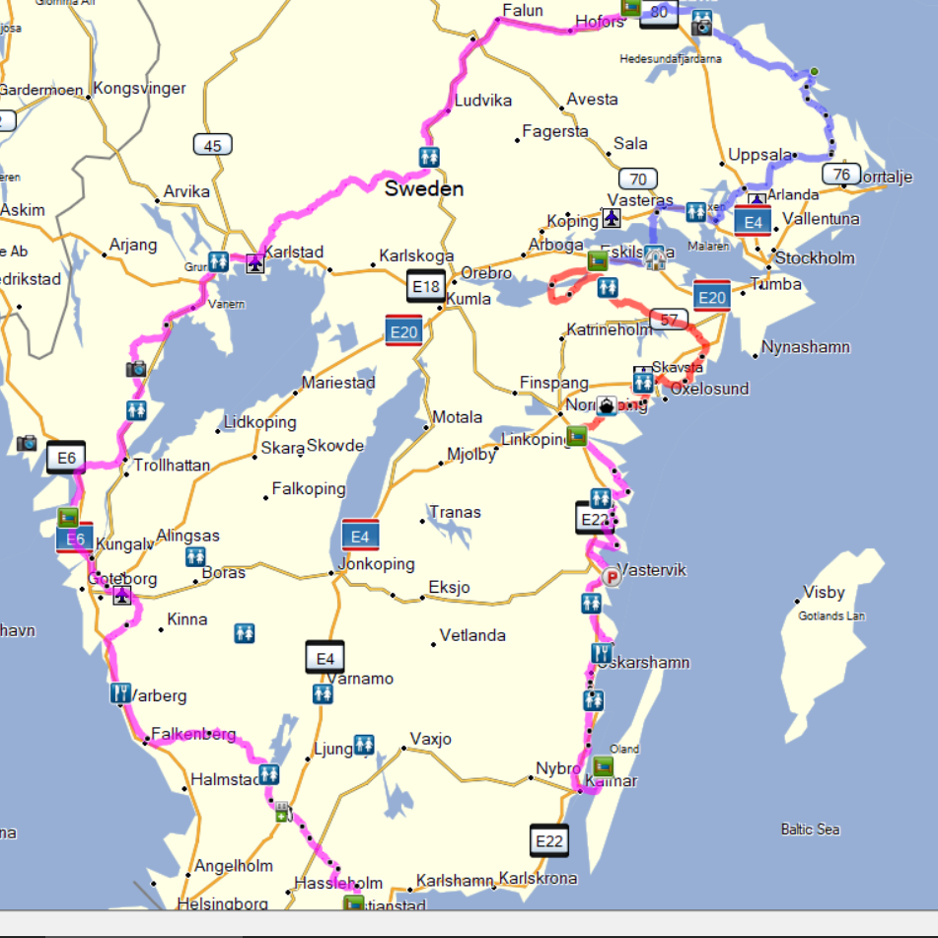
Date |  | Activity |  | Location |  | Hotel |  |  | Info & Reservation
June 27 |  | Meeting & Greating Day |  | Bäckaskog |  | Bäckaskog Slott |  |  |  | www.backaskogslott.se
June 28 |  | One day tour exploring Skåne County |  | Bäckaskog |  | Bäckaskog Slott |  |  |  | www.backaskogslott.se
June 29 |  | Relocation Tour 1 to Region West |  | Stenungsund |  | Stenungsbaden |  |  |  | www.stenungsbaden.se
June 30 |  | One day tour exploring the Swedish west coast |  | Stenungsund |  | Stenungsbaden |  |  |  | www.stenungsbaden.se
July 01 |  | Relocation Tour 2 to Region North |  | Sandviken |  | Högbo Brukshotell |  |  |  | www.hogbobrukshotell.se
July 02 |  | One day tour exploring a part of Norrland |  | Sandviken |  | Högbo Brukshotell |  |  |  | www.hogbobrukshotell.se
July 03 |  | Relocation Tour 3 to Region Mid |  | Eskilstuna |  | Comfort Hotell |  |  |  | comfort-hotel-eskilstuna/
July 04 |  | One day tour exploring the Lake Mälaren area |  | Eskilstuna |  | Comfort Hotell |  |  |  | See Above
July 05 |  | Relocation Tour 4 to Region East |  | Söderköping |  | Söderköpings Brunn |  |  |  | www.soderkopingsbrunn.se
July 06 |  | One day Exploring & Relocation Tour 5 to Öland |  | Ekerum |  | Ekerum Resort |  |  |  | www.ekerum.com
July 07 |  | Day activities at Öland and the Anniversary Party |  | Ekerum |  | Ekerum Resort |  |  |  | www.ekerum.com
July 08 |  | Breakfast and Farewell Day |  | Ekerum |  | Ekerum Resort |  |  |  | www.ekerum.com

June 29 Bäckaskog – Stenungsund
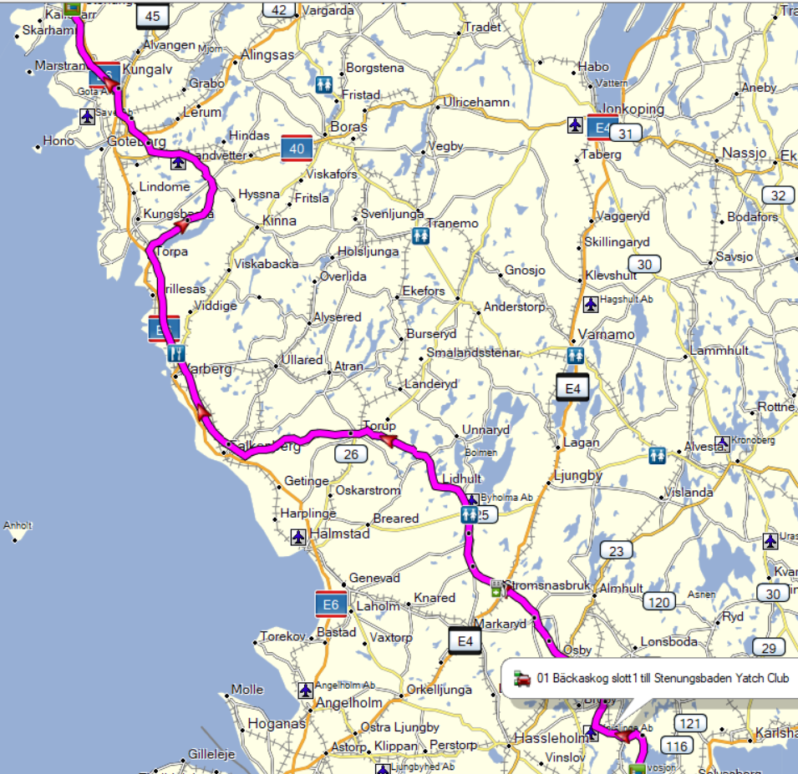

July 01 Stenungsund – Högbo

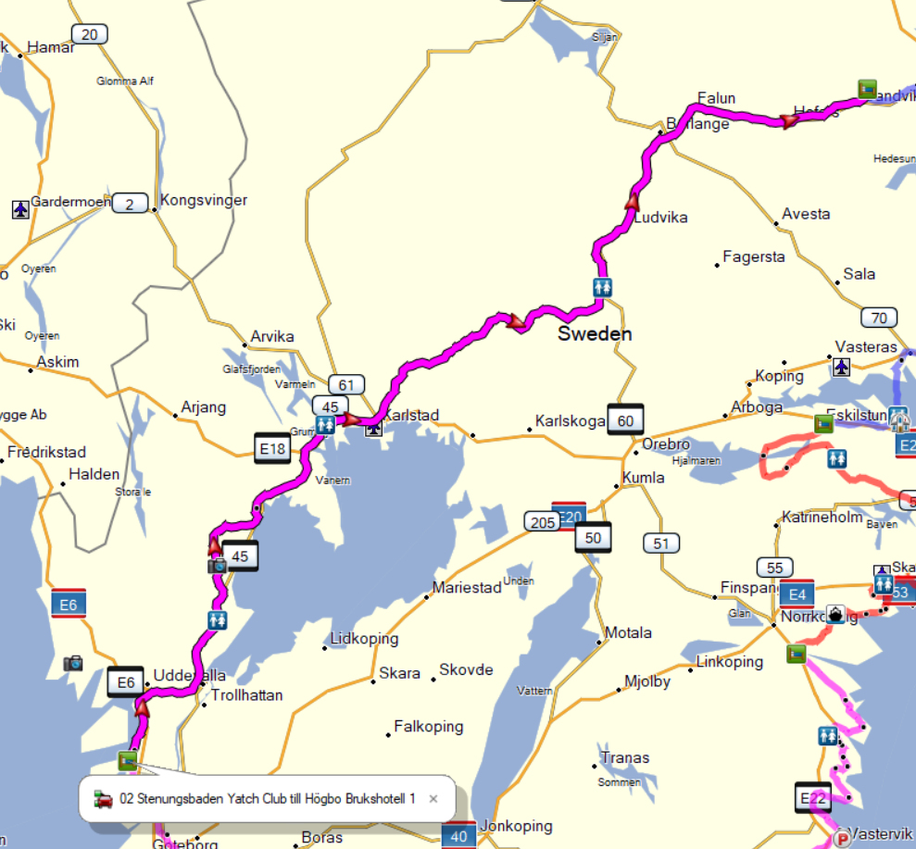

July 03 Högbo – Eskilstuna

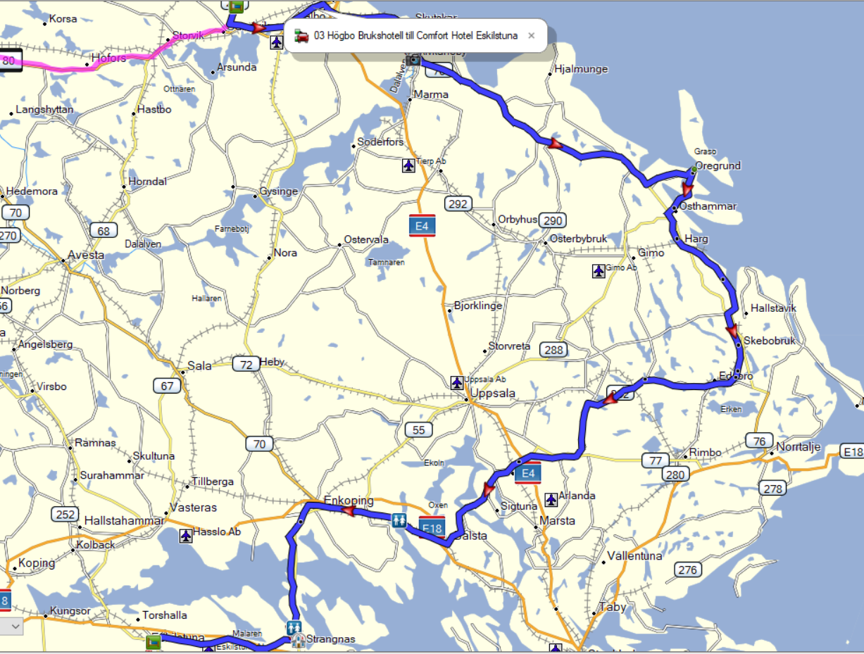

July 05 Eskilstuna – Söderköping

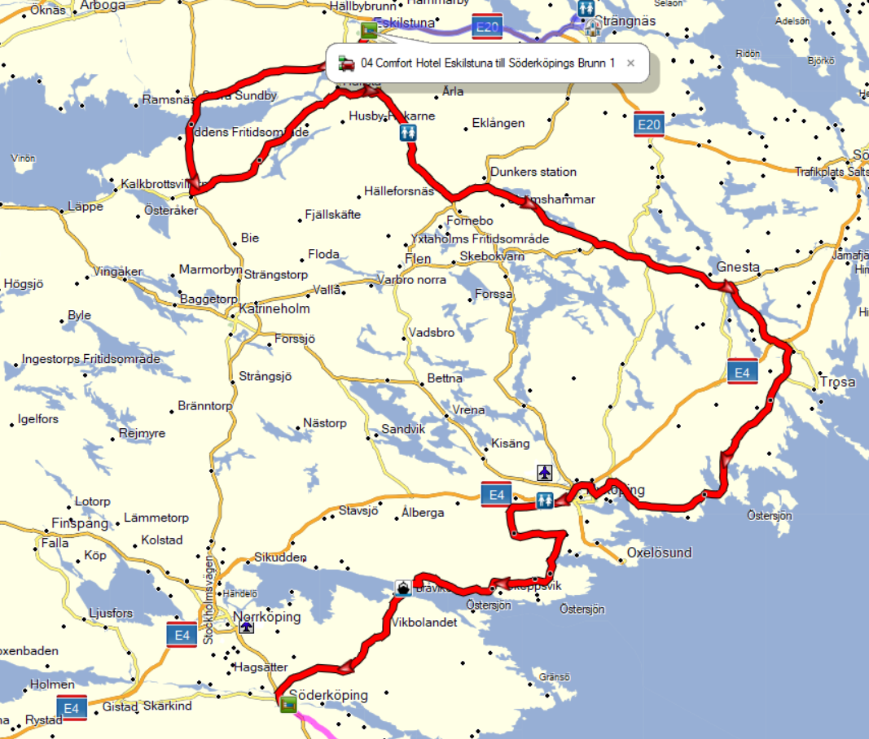

JULY 06 Söderköping – Ekerum Öland

